CLIMATE CHANGE ADAPTATION

A manual for trainers

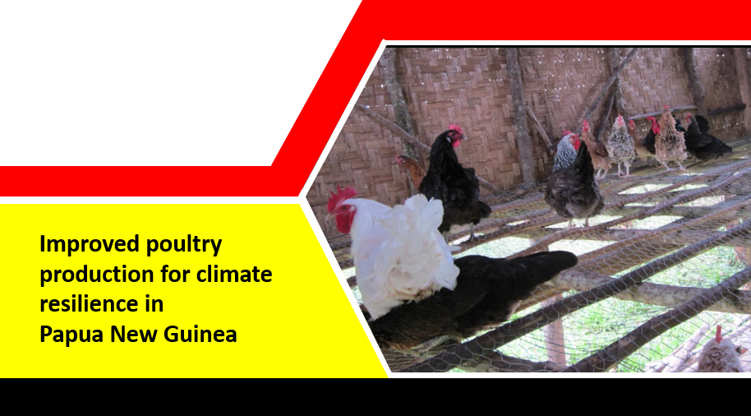

|  |  |
| --- | --- |
|  |  |

Supported by the European Union

**Janet Pandi, NARI Livestock**

**Acknowledgements**

**NARI gratefully acknowledges the generous support of the people of the European Union in the Action - Strengthening food production capacity and the resilience to drought of vulnerable communities.**

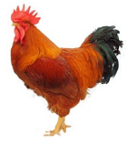

**Table of Contents**

[Introduction 1](#_Toc532277845)

[Outline of the Training Sessions: 1](#_Toc532277846)

[Session 1: Know your poultry- Raising Village Chickens 3](#_Toc532277847)

[Learning goals 3](#_Toc532277848)

[Know your Poultry 3](#_Toc532277849)

[Village Chickens 3](#_Toc532277850)

[Session 2: Poultry Housing 5](#_Toc532277851)

[Learning goals 5](#_Toc532277852)

[Housing 5](#_Toc532277853)

[Session 3: Feeding – Food, Water and Related Issue 9](#_Toc532277854)

[Learning goals 9](#_Toc532277855)

[Feeding 9](#_Toc532277856)

[Session 4: Breeding and Reproduction 13](#_Toc532277857)

[Learning goals 13](#_Toc532277858)

[Breeding 13](#_Toc532277859)

[Session 5: Egg Management 18](#_Toc532277860)

[Learning goals 18](#_Toc532277861)

[Egg Management 18](#_Toc532277862)

[Session 6: Diseases Management 24](#_Toc532277863)

[Learning goals 24](#_Toc532277864)

[Disease Management 24](#_Toc532277865)

[Treating parasitic worm infections of birds 24](#_Toc532277866)

[Session 7: Welfare of chickens during drought 26](#_Toc532277867)

[Learning goals 26](#_Toc532277868)

[Summary 27](#_Toc532277869)

### Foreword

|  |
| --- |
| Please don’t start a training without reading –  Training villagers in PNG**!**  **You can download a copy here-**  [**http://gutpela-png-gaden.net/library/record/view/id/43**](http://gutpela-png-gaden.net/library/record/view/id/43)  **Muntwiler and Askin, 2004. Training villagers in PNG - a manual for trainers.**  **Remember, training is much more than giving technical information. The Muntwiler and Askin manual will provide lots of useful information to assist the process of your training**. |

Determine your purpose for keeping poultry in order to select a breed. For egg-laying hens, select breeds that are productive egg layers. For meat birds, select breeds that have been cultivated for game. After determining the breed and quantities, keeping in mind the choice of your breed and the quantity of chickens you intend to keep will determine the size of your chicken housing and the need to know how to generally care for your flock.

# Introduction

This manual is geared towards expanding the knowledge base of TOTs (Trainers of Trainees) on improved production practices and techniques of raising village poultry with the overall goal of up skilling and building capacity of farmers/trainers to be climate smart.

The main focus of the training is on smallholder or village back yard poultry such as raising village chickens and Muscovy ducks for production of eggs, meat and for breeding foundation stock with the overall goal of ensuring that famers are able to still maintain production during climatic changes such as drought. It is envisioned that with this set of improved husbandry skills and knowledge on farming of poultry (Muscovy Ducks and Village chickens) TOTs and innovative farmers will be better equipped to train poultry farmers to be more aware and resilient to keeping poultry during major climatic changes so that farmers are able to still raise poultry for eggs or meat and or as a source of income so that they are resilient to challenges posed by changes in weather patterns.

The manual is devised in such a way that it covers basic aspects of poultry production systems and where applicable useful tips on how to improve these basic practices to get the more out of your breeding flock. The training will be delivered in an interactive mode where TOTs and innovative farmers are involved with group discussions, farm visits, and demonstrations of basic skills in handling poultry along with training notes.

## Outline of the Training Sessions:

This training will cover the following issues which will be delivered in sessions. There are seven sessions to cover in this manual.

|  |  |
| --- | --- |
| Outline🡪 | |
|  | * Know your Poultry: Raising village chickens * Factors leading to low Productivity in Village Chickens * Breeding * Egg Management * Feeding * Housing * Disease and Welfare |
| A glossary of terminology used throughout the training is provided at the end. Where applicable additional information such as NARI Toktoks or leaflets which be given under the Appendices. | |

# Session 1: Know your poultry- Raising Village Chickens

## Learning goals

|  |  |
| --- | --- |
|  | Farmers will 🡪 1. Understand the context of village chicken production in PNG  2. Know the various ways under which village chickens are raised  3. Know the benefits of keeping chickens |

## Know your Poultry

Raising Chickens come with lot of benefits such as a source of fresh, healthy meat and eggs and extra source of income, by way of eggs, meat and bird sales. Backyard flocks are also great for gardens. Chickens, which scratch for insects and occasionally eat lizards and mice, offer insect and small pest control. Chickens often eat leaves and can therefore offer weed control in flower beds or grassy lawns. Chicken manure is high in nitrogen and can serve as a nutritious independent fertilizer or a balanced addition to compost mix. The bird’s natural scratching behaviour is also helpful for turning and aerating the soil.

## Village Chickens

Village chickens are the most common type of livestock or poultry kept in many rural areas. Village chickens are often times referred to as rural, indigenous, scavenging, free-range, traditional or family chickens, and have various names in local languages. In PNG, there are commonly referred to as ‘Ples Kakaruk.’

|  |  |
| --- | --- |
|  | Different types of production systems in PNG Village chicken production is often referred to as ‘Backyard or Family Poultry and has three distinct types of production system which are namely;   * Free-Range Extensive Systems- farmers keep poultry under free-range conditions, where birds are not confined and can scavenge for food over a wide area. Birds may roost outside, usually in trees, and nest in the bush. The flock contains birds of different species and varying ages. * Backyard Extensive Systems-Poultry are housed at night but allowed free-range during the day. They are usually fed a handful of grain in the morning and evening to supplement scavenging. * Semi-Intensive Systems- A combination of the extensive and intensive systems where birds are confined to a certain area with access to shelter. They are commonly found in urban and peri-urban as well as rural situations. In the “run” system, the birds are confined in an enclosed area outside during the day and housed at night. Feed and water are available in the house to avoid wastage by rain, wind and wild animals.   Free-Range Extensive Systems  Backyard Extensive Systems  Semi-Intensive System  ***Figure 1. The different production system of village chicken farming*** |
|  | Thinking together  * Individual perspective on why they are keeping poultry |
|  | Working together Discuss together.   * Issues arising with the different production systems |

# Session 2: Poultry Housing

## Learning goals

|  |  |
| --- | --- |
|  | Farmers will 🡪  * Importance of housing to your flock * Basic housing structure or design * Recommended spacing and stocking density * Ventilation * Brooders, nesting boxes, perches –importance of perches |

## Housing

Housing village chickens at night will protect them from rain and the cold and from predators such as dogs, rats, snakes and other wild animals and from theft.

### Types of housing

Different types of house can be built. Chicken houses built close to the ground are suitable. It is vital have build a drain around the house so that it has proper drainage and the area is dry during the rainy season. A house which is about 4m long, 1m wide and 1.5m high can hold 8–10 adult birds if they are kept enclosed all day, or about 20 for overnight housing. The house can be completely covered with wooden slats or be partly open with netting or woven bamboo.

|  |  |
| --- | --- |
| Constructing a chicken house | |
|  | Simple rules for building a chicken house:   * The size of the house will depend on the number of birds, and whether they are to be kept in the house during the night. * Houses can either be built on the ground or raised on poles. * If built on poles, it should be at least 1m above the ground but not so high that the inside of it cannot be reached by the farmer. * A house can be built cheaply using local materials such as tree and bush branches or sago thatch and thatch grass. * Always remove the bark from timber used to construct the houses so that pests and parasites such as ticks and mites will have nowhere to hide. |

**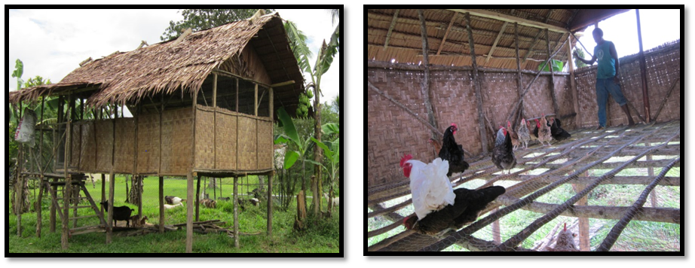**

***Figure 2. Chicken house built one meter above ground to provide protection from predators and free from diseases, a typical low nigh house for chickens under village conditions***

|  |  |
| --- | --- |
| Maintaining a chicken house-useful tips | |
|  | Cleaning the chicken house helps prevent and control diseases.   * Keep the area around the house clear of grass and bush to keep snakes and rats away * Remove droppings and litter from inside the house regularly * Break up the manure so it dries quickly. This helps to kill infectious agents within the manure and helps control flies. Flies will not be a problem if the manure is kept dry. * Compost manure for at least three weeks. Digging composted manure into vegetable gardens will fertilize the soil, leading to better plant growth. * Fumigate the chicken house regularly with smoke after letting the birds out (by lighting a fire under elevated chicken houses) to control external parasites. This can be done every 6-8 months. * Place wood ash or lime on the floor and walls to repel external parasites and to make it easier to remove manure when cleaning. * Tobacco leaves are also effective in controlling pests. |
| Providing nest box | |
|  | Providing clean nests in safe places helps control and improves productivity. The quality of eggs is better if they are clean. Pad the nests with clean, dry nesting material (eg. leaves, straw, old cloth or even sand) to help keep the eggs warm and minimize the risk of breakage or contamination.  Here are some tips:   * A sufficient number of nests should be provided in the chicken house and must be located protected from the elements and predators * Nests should be constructed in a way that protects the eggs from cooling from below or from falling out of the nest. * Nests should be cleaned regularly. * If there has been a serious outbreak of disease or a heavy infestation of external parasites (eg lice), the nests must be burnt and replaced. * Eggs intended for brooding should not be completely removed. Leave at least one egg in the nest. |

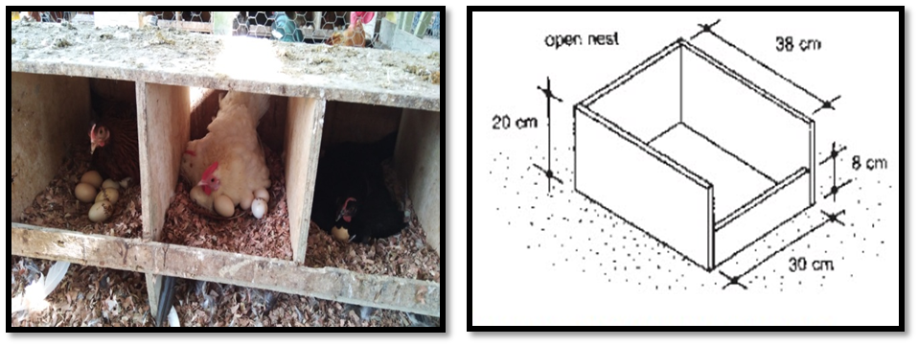

***Figure 3. Building a nest box for chicken to lay egg, provide a safe place and helps control and improve productivity.***

|  |  |
| --- | --- |
| Protection from predators | |
|  | Predators are a major problem in village chicken production, causing almost unavoidable losses in free-range systems. Predators of chickens include other birds, mammals and reptiles. Protective measures should be designed according to which predators are common in the region and how these predators hunt. Farm animals such as dogs should be kept under control as they are a threat as well.  Implementing the following measures will help reduce losses due to predators:   * Construct shelters to offer protection from predators. * Clear the area around the chicken house. * Do not provide feed or water in extensive open areas where chickens can be attacked easily by birds of prey. |

|  |  |
| --- | --- |
| Theft | |
|  | In areas where theft is a problem, due to Biosecurity issues, farmers are discouraged to keep birds during the night in their homestead. Keeping the birds in a separate but safe place is therefore strongly recommended. Anti-theft measures may include the following:   * The chicken house could be fitted with a very noisy opening that will alert the owner in case of attempted theft. * Roosts could be placed at more than an arm’s length from the opening so that birds are out of reach of thieves. * The chicken house could be built where the owners can see it by peeping through their window. |
|  | Thinking together  * Group discussion on the single most important factor on housing in relation to their purpose of keeping poultry |
|  | Working together Divide into groups to build;   * Brooders, * Perches and * Nesting boxes |

# Session 3: Feeding – Food, Water and Related Issue

## Learning goals

|  |  |
| --- | --- |
|  | Farmers will 🡪  * Understand nutrient requirements of chicken * Understand how to utilize locally available feed resources * Understand how to formulate supplementary feed |

## Feeding

Chickens need adequate feed for maintenance (eg. to move around, renew their feathers, maintain body growth and fight diseases) and for production (to grow and to produce eggs). Chickens require carbohydrates, proteins, fats, minerals and vitamins in their feed.

|  |  |
| --- | --- |
| Nutrient requirements | |
|  | The proportions of carbohydrates, proteins, fats, minerals and vitamins that the bird needs in their rations will depend on the age of the bird and whether it is being raised for meat or for laying eggs:   * From hatching (1 day old) to 3 months of age, birds are growing. They need feed that contains a large amount of protein. The feed should have a protein content of about 18.5%. * After 3 months old, birds raised for meat need less protein. Their feed should have a protein content of about 14%. * After 3 months old, birds laying eggs need more protein and minerals than birds raised for meat. Their feed should have a protein content of about 16.5%.   There are feed resources available for feeding chickens at all levels of production. Farmers using the semi-intensive system who make their own feed must base the rations on home produced feed resources obtained locally. In backyard systems, available resources should be supplemented with appropriate nutrients as necessary. Food products from household waste fed to free-range birds should also be supplemented.  Birds that are allowed to wander around free and eat whatever they can find do not grow properly. They produce little meat and few eggs. In order to get good meat and egg production from birds, they must be confined in houses and given food that contains the necessary nutrients.  A complete chicken feed must contain a balance of nutrients, or the birds will begin to show signs of nutrient deficiencies (shortage). All animals can suffer from deficiency problems, but in birds a deficiency very quickly leads to:   * Low body weights * Poor health * Leg problems * Poor feathering * Poor egg production * Eggs with thin shells * Infections |

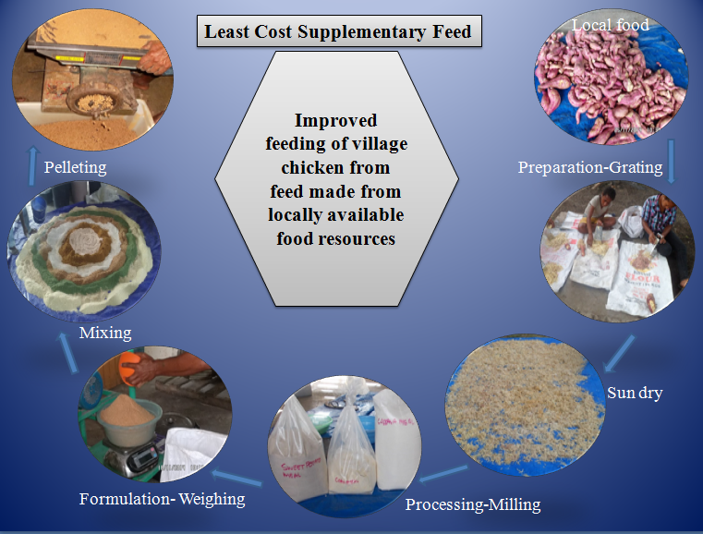

***Figure 4. Using locally available food resources to process and formulate a simple supplementary diet for chickens***

|  |  |
| --- | --- |
| Rations | |
|  | Rations will change with the requirements of the bird. Young birds need rations that are rich in protein, while laying birds need plenty of minerals. Some examples of rations are given in Table 2.  The following are some important things to remember about rations for chickens:   * Feed mixture should be thoroughly mixed and made as crumble or pellet form before feeding it to chickens. * Whole grain can be scattered over the run. This encourages birds to scratch the ground as they feed, so they take in minerals from the soil. * Green vegetable can be hung up in the run or chicken house. This encourages the birds to peck at the bundle of green vegetables and not at each other. * Always clean out unused feed every day. |

|  |  |  |  |  |  |  |
| --- | --- | --- | --- | --- | --- | --- |
| Age of bird | Carbohydrate | | Plant protein | Animal protein | | Minerals |
| Up to 8 weeks | 7 parts | | 2 parts | 1 part | | 0.25 part |
| 8-12 weeks | 8 parts | | 1.5 parts | 1 part | | 0.25 part |
| Laying | 8 parts | | 1.5 parts | 0.25 part | | 0.50 part |
| Feeding Requirements | | | | | | |
| Age of bird | | Amount required/day (gram) | | | Amount eaten/day (gram) | |
| 1-3 Week | | 10-30g | | | 12-35g | |
| 4-6 Week | | 30-40g | | | 35-50g | |
| 7-9 Week | | 30-40g | | | 50-60g | |
| 10-16 Week | | 30-50g | | | 55-70g | |
| 17-28 Week (Grower) | | 40-60g | | | 60-80g | |
| 29 and over (Adults) | | 50-60g | | | 80-100g | |

***Table 2. Example of village chicken feed formulation rations and feed requirement of birds according to different sizes***

|  |  |
| --- | --- |
|  | Water Birds must always have access to clean, fresh water. Each bird needs about 250ml of water every day. In hot weather, they need double this amount to 500ml. Problems caused by poor feed (nutrient deficiency) As you have learned, birds need the correct balance of nutrients in order to grow properly, to produce good quality meat and to produce large numbers of good quality eggs. If the feed does not have the correct amount of nutrients, birds can develop nutrient deficiencies. The following are the effects of particular nutrient deficiencies:   * **Protein deficiency** A lack of protein in the feed can cause birds to show these signs: * Become weak and develop infections * Grow slowly; causing a reduction in meat production * lay fewer eggs or stop laying eggs   To prevent protein deficiencies, it is important to feed birds a balanced diet. The signs of a protein deficiency are similar to the signs caused by some other serious diseases that affect birds.   * **Mineral deficiencies** Lack of calcium in the feed can: * Cause the bones of the leg to curve, making it difficult for the bird to walk properly. * Result in soft –shelled eggs or eggs without shells.   Eggs with a soft shell can be easily broken and eaten by other birds. If this happens, chickens can develop a habit of eating eggs, which can become a problem.  To prevent these problems, birds must be given plenty of minerals in the form of sand, powdered shell, crushed coral sand, crushed eggshells or bone. If birds are allowed to scratch for grain, they will take in the minerals they need from the soil in the run.   * **Vitamin deficiencies** if vitamins are not present in the feed, then: * Birds do not grow well, are weak, and the feathers are ruffled * The toes curl inwards, and birds have difficulty moving * Chest problems can occur, and birds will have nose and eye discharges * Birds may start picking out their own feathers * Large numbers of young birds may die * Egg production may decrease * Fertilized eggs may not hatch   These problems can be prevented by adding commercially produced vitamins to the feed mix, or providing the birds with green vegetables in addition to the feed mix. |
|  | Thinking together  * Discuss in groups and identify locally available food resources that can be used for village chicken diets * In groups, the identified food resources are put into their nutritional groups of energy, protein and vitamins/minerals |
|  | Working together Participate together.   * Formulate a simple supplementary diet for village chicken based on the formulation ratio given in table 2. |

# Session 4: Breeding and Reproduction

## Learning goals

|  |  |
| --- | --- |
|  | Farmers will 🡪  * Understand the context of breeding and their purpose f keeping chickens * Know how to select good breeding cockerel or hen * Understanding issues affecting survivability of your flock |

## Breeding

Many chicken breeds are perfectly suited for backyard flocks. Choosing the right breed for your backyard flock solely depends on your needs. Chicken breeds can be divided into two basic categories: birds for meat and those for eggs.

|  |  |
| --- | --- |
| What is breeding? | |
|  | Breeding is the selection process or mating of chickens to generate more stock. Natural breeding occurs naturally without any intervention from the farmer. Artificial breeding or selection occurs when a farmer is controlling the mating process with a breeding goal in mind. There are basically two types of breeding;   * Cross-breeding is the mating of chickens that are not related whilst * In-breeding -is the mating of related chickens, e.g. a mother and son, father and daughter, or brother and sister.   In-breeding causes problems such as poor growth of chicks, susceptibility to disease, lameness etc. To avoid in-breeding, change cockerels every four to five months. This will ensure that the cockerels do not breed with their daughters when they become sexually mature. The only sexually mature male in the flock should be a carefully selected cockerel. Breeding and Production facts  * Hens weigh no more than 1.2–1.5kg at the point of laying & a cockerel will weigh around 1.4–2.5kg at the age of maturity; * Hens will generally lay their first egg at the age of or between 22–30 weeks after hatch and lay 2 to 4 clutches of 5 to 20 eggs a year; * Hens will find dark, quiet places for laying eggs and brooding; * Incubation takes 21 days and chicks will follow their mothers immediately after hatching. * Only 20–50 per cent of chicks hatched will reach adulthood * 85 per cent of these losses occur in the first three weeks of life. Adult mortality is very variable and depends on specific local conditions and the occurrence of disease.  |  | | --- | | **Helpful Tip**  More eggs and chicks can be produced if chicks are removed from the mother 1-7 days after hatching. The period will depend on the farmer’s capacity and ability to take care of the chicks. | |

|  |  |
| --- | --- |
| Breeding | No. of days |
| Egg laying | 21 days |
| Brooding 7 days | 7 days |
| Incubating | 21 days |
| Resting | 10 days |
| Total number of days for a cycle | 59 days |

***Table 2. An example of a timetable of one complete laying cycle***

|  |  |
| --- | --- |
| How to source and select chickens for brooding and breeding | |
|  | |  | | --- | | **Helpful tips**  On hen can produce six clutches in a year and under good management, around 15 chicks per clutch can survive. This means one hen can produce 90 chicks in a year.  A hen will start laying 7 to 14 days after it stops taking care of chicks, regardless |   Brooding is the act of a hen sitting on eggs to incubate them. At a certain age, hens begin to exhibit brooding behaviour.   * On average, hens lay about ten eggs before beginning to brood. * Once the brooding behaviour begins, all eggs begin to incubate at the same time and are able to complete the incubation period at the same. * To facilitate brooding behaviour, you must separate the brooding hens from the rest of the hens. * Brooding hens are often kept in brooders/nesting boxes, which offer more comfort and peace.   The bird’s age, breed, and moulting period will determine its ability to lay eggs. Village chickens have good brooding and mothering ability and are a good breed for both egg production and hatching of breeding stock for distribution of young hatchlings to other farmers. |
| Selection of chickens for breeding | |
|  | Birds selected for breeding should outperform other birds in the flock:   * Must be fast-growing compared with birds of the same age. * Must have a higher live weight than other birds of the same age in the flock.  |  | | --- | | ***Helpful Tip***  *To increase Egg production, brooding behaviour must be reduced. This is achievable by separating the broody hen from the rest of the flock and placed in a pen without a nesting box* |  * Must show good early feathering as this will ensure that they are able to keep warm at an early age. * Should have a good appearance with no signs of illness, disease or pests. * Males should be known for their aggressiveness in chasing and courting females or should come from cocks that were aggressive. * The females selected for laying eggs should be known to lay large clutches of at least 12 or more eggs, or should have come from parent hens with large clutches. |

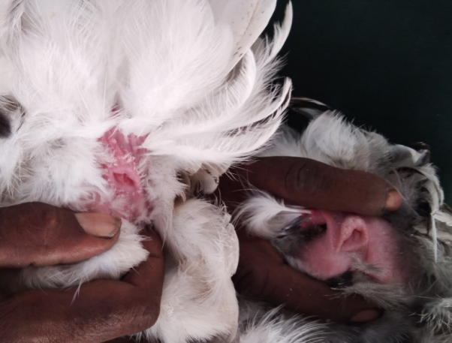 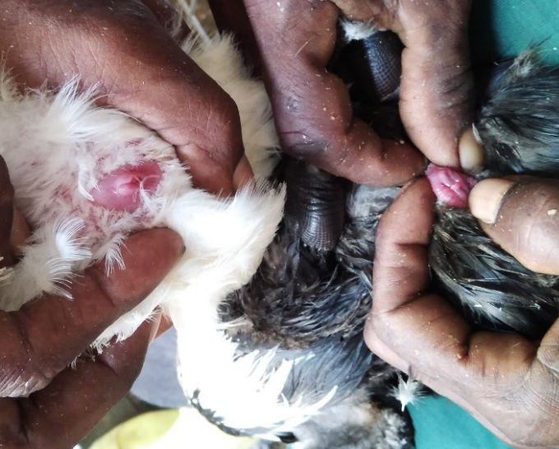

***Figure 5. Gender sexing of male and female chicken and duck***

|  |  |
| --- | --- |
| Factors leading to low Productivity in Village Chickens | |
|  | Previously (Session 1), we identified the type of production systems in PNG associated with raising village chickens and the characteristics of such system. Because of this type of system, several factors come into plays which often can influence productivity of a flock. Some of these factors are;   * Poor understanding and knowledge on how to or methods in the control and treatment of diseases/disease outbreaks * Poor nutrition * In-breeding within the flock * Hens being left to brood chicks for too long * Lack of a good plan for production and sales (farmers feel their chickens are not profitable) * Poor or lack of housing (Prone to or vulnerable to elements and theft) |

|  |  |
| --- | --- |
|  | Thinking together Together discus on;   * What type of poultry are kept and personal perspectives on whether these breeds are good egg layers, meat types of both? * Discuss major issues influencing lack of breeding stock on farm * Discuss what are the major problems associated with raising village Chickens; List these problems and rank them in order of importance; * Interventions to reduce or improve issues influencing low productivity of a flock |
|  | Walking together Visit to the farm;   * Feather sexing of hatchlings * Identification of gender/sex * See set up of Chicken coop/run |

# Session 5: Egg Management

## Learning goals

|  |  |
| --- | --- |
|  | Farmers will 🡪  * Understand the importance of caring for eggs * Know the candling process and how to identify fertile eggs * Describe the egg production of a hen; * Describe how to use an incubator |

## Egg Management

The welfare of hens in brooding is critical to achieve a better hatchability**.** Feed and water provided in closeproximity to the hen will keep her in better condition and reduce embryo damage due to thecooling of the eggs if she has to leave the nest to scavenge for food.The hen keeps the eggs at the correct humidity by splashing water on them from her beak, this is critical for providing her with easy access to water. The incubation period for chicken eggs is 20 to 21 days.

|  |  |
| --- | --- |
|  | Egg production in the chicken A well fed layer hen will begin to produce eggs when she achieves puberty at 4-5 months old, even if she has not been mated. The hen will produce one egg every 26-28 hours, but will not produce eggs in the dark. Normally, the hen will lay a clutch of eggs and become broody.  A hen’s egg production is at its height at 8.5 months old. After this age, the egg production begins to decrease. At 18-20 months old, chickens will stop producing eggs and they will moult (lose their feathers). Egg production is normally highest during the first year of production (240 eggs per year) and then falls each year as the hens get older.  The following describes how an egg is produced in a chicken:   * The yolk of the egg (yellow part of the egg) is produced in the ovary of the hen and released into the reproductive tract. * The white part of the egg is formed in the oviduct. * The shell of the egg is formed in the uterus, which is also known as the shell gland. * Eggs pass through the vagina and are laid through the cloaca. |

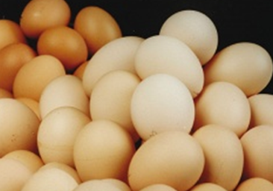 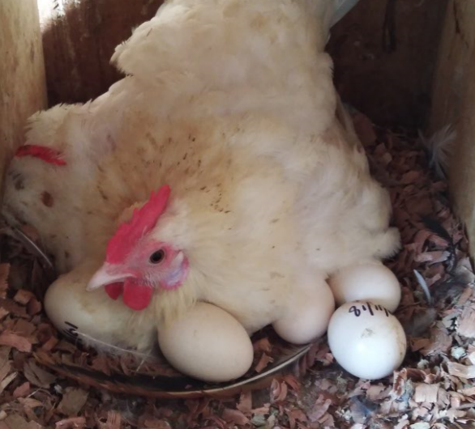

***Figure 5. A good hen brood her egg in a nest box for quality production***

|  |  |
| --- | --- |
| The quality of eggs | |
|  | Eggs should be kept in a cool place. If placed in a refrigerator, chicken eggs will stay fresh for 3 weeks. The following points are useful to note:   * An egg produced by a female bird kept without a male is called a non-fertile egg. A non-fertile egg will keep fresh for a long time. * Eggs from a female that has mated with a male bird are alive (that is, fertilized). The young chick will start to grow if the fertilized egg is kept in a warm place. * To check if eggs are fertilized, hold them against a light (see more information is the section, Candling). If the egg has been fertilized, the contents of the egg may appear pink in colour, or you may be able to see the young chick developing inside the egg. * Dirty eggs should be cleaned before they are sold or used. Never wash dirty eggs in warm water. Wiping eggs with a damp cloth is also not good practice because germs and dirt can be transferred between eggs on the damp cloth. * Remove dirt by gently rubbing the dirty areas with fine sandpaper. * If eggs are placed in a container of cool, clean water, the bad eggs (eggs that cannot be eaten) will float to the top of the water, while the good eggs stay at the bottom. |

|  |  |
| --- | --- |
| The broody hen | |
|  | A hen is brooding when she sits on her eggs in a nest to incubate them. Natural incubation is the simplest way to hatch small numbers of eggs. The broody hen can be used to incubate and hatch her own eggs or those from another bird. A hen can incubate 12-15 chicken eggs.  A good test to check the broodiness of the hen is to put some white balls, or a few hardboiled eggs, in its nest for a day or two. If the hen stays in the nest and is not easy to move off, she is a good brooder. You can then replace the balls and hardboiled eggs with 10-15 fertile eggs. The eggs should be checked first to see that they are fertile. Care of brooding hens The broody hen is kept in a nesting box. Take the hen off the nest for 20 minutes each day to give her feed and water. How to use an incubator (For hatching eggs) Natural incubation by the female bird is the simplest way of hatching a small number of eggs. To hatch a large number of eggs, an incubator that is heated by kerosene or electricity can be used.  Eggs being hatched in an incubator must be checked to make sure they are developing healthy chicks. The condition of the eggs in the incubator can be checked by candling method  If a community has a small incubator, it should be able to incubate and hatch eggs with good results if the steps below are followed:   1. Run the incubator for a few days to make sure the temperature is steady at 39.5 degree Celsius. 2. Make sure the incubator is level and the temperature of the room where it is kept stays fairly constant and below the temperature of the incubator. 3. Make sure you have enough kerosene to run the incubator for the required length of time or that your electricity supply is reliable. 4. Choose eggs that are not too small, not too large and do not have thin or cracked shells. 5. Only incubate eggs that were laid over the previous 7 days. 6. Candle the eggs before placing them in the incubator to make sure that the eggs have been fertilized. 7. Make sure the thermometer is level with the eggs. 8. Make sure that there is always water in the water tray inside the incubator. This will ensure that the moisture content of the air in the incubator is correct. 9. Do not touch the eggs with a dirty hand or after handling kerosene. 10. Turn the eggs twice a day for the first 18 days and move them around (as the mother bird would do). From day 18, chicken eggs should not be touched and the incubator should not be opened.  Candling (checking if eggs are fertilized) Sometimes, eggs can be incubated but after a lot of care no young hatch because the eggs were not fertile. This can be avoided by checking the eggs before putting them to incubate, and also during their time in the incubator.  You will need a small box with an electric light, torch or other source of light in it. If you hold the egg against the light (or strong sunlight), you will be able to see if it is fertile or not. The fertile egg will look pinkish in colour. Later, as the egg is incubated, there will be a dark shadowy area when the embryo is developing properly. As the embryo develops and hatching time approaches, the inside of the egg will appear dark, except the air cell. You will need to candle (check) eggs:   1. Before putting them in the incubator. 2. 4-5 days after putting them in the incubator. Discard eggs that are still clear. 3. 10 days after putting them in the incubator. Discard any that are not well developed by then. 4. On day 18 of the incubation period. Do not open the incubator again between day 18 and hatching if incubating chicken eggs. |

**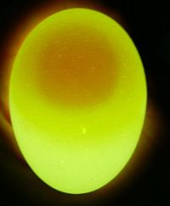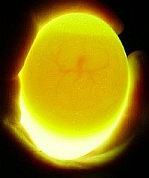 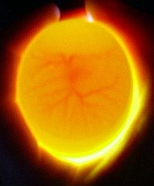**

***Figure 4. When candling the eggs, you should handle them gently and not allow them to cool too much.***

|  |  |
| --- | --- |
| Brooder (For keeping very young birds) | |
|  | Young chicks or hatchlings need to be kept in a brooder for a few weeks. The brooder provides the heat and protection the chicks would receive from the mother. In the brooder, young birds are kept warm and protected from animals and the weather.  You can buy a brooder or make your own.   * A simple brooder is made from a heavy box or basket, with a layer of sawdust or newspaper placed on the bottom of it. * A hurricane lamp (kerosene lamp) or electric light bulb is placed in the box or basket to supply heat. * To protect the young chicks from predators such as cats, rats and dogs, be sure to cover the brooder with mesh wire. * Newly hatched chicks will require an area of 20x 20cm for each bird. A box of 1 x 1 m will be big enough for 25 chicks. * The lamp is surrounded with wire mesh to stop the birds from touching it. Troughs (containers) for feed and water are placing in the brooder. Make sure the troughs provide 2.5 cm of feed trough space and 0.5 cm of water trough space for each bird. The birds can be kept in the brooder until they are 2 weeks old. * The position of the chicks inside the brooder will tell you if they are warm enough. If the temperature is correct, the chicks will be spread evenly throughout the brooder. If the temperature is too hot, the chicks will move away from the lamp. If it is too cold, the chicks will huddle around the lamp. If the chicks huddle on one side of the brooder, this is a sign that there may be cold breeze blowing into the brooder. * When the birds reach 2 weeks of age, they do not need the heat of a lamp and are too big for the brooder. They should be placed in a chicken coop, poultry house or a fenced area (run).   C:\Users\maima.sine\Pictures\Poultry images\IMG_20181130_084522.jpg C:\Users\maima.sine\Pictures\Poultry images\IMG_20181130_084303.jpg  ***Figure 5. After 2 weeks of brooding, chicks should be transferred to spacious pen***  Put an open box on its side in the house or the run, and cover the floor of the box with sawdust, wood shavings, hay, and paper, cardboard or straw. The young chickens can go into the box for warmth when they need it.  Make sure the troughs for the young birds provide 2.5 cm of feed trough space and 1.3 cm of water trough space for each bird. Where farmers are using tube feeders and bell waterier, they should allow one tube feeder for each 80 birds and one bell waterier for every 110 birds. |

|  |  |
| --- | --- |
|  | Thinking together  * Discuss Importance of brooding * How to incubate eggs naturally and artificially |
|  | Walking together Discuss and together construct a brooder.   * How to construct brooder |

# Session 6: Diseases Management

## Learning goals

|  |  |
| --- | --- |
|  | Farmers will 🡪  * Understand importance of disease and basic management practices to minimize disease on farm * Recognise and identify disease symptoms and how to treat your chickens |

## Disease Management

Chickens are infected by internal and external parasites. Internal parasites include roundworms and coccidia. The digestive system of chickens can be infected with a number of different types of roundworms**.** Heavy infections cause weight loss, diarrhoea and poor egg production. Both chickens and ducks can be infected with very small parasites called coccidia, which leads to loss of feathers, drop in weight and low numbers of eggs.

External parasites include lice, mites and ticks. These parasites will hide in the walls, floors and bedding of bird cages and houses. In order to control them, it is necessary to keep these places clean and kill any parasites found in the houses.

Diseases have a negative effect on chicken production, and farmers should ensure their farms are as free from disease as possible and know what to do with sick or deceased birds to ensure Biosecurity on farm. Any disease outbreak means a drop in production translating to a loss for the farmer.

|  |  |
| --- | --- |
| Parasitic worms of chickens | |
|  | Worm infections are a serious problem in young birds and cause poor appetite, weight loss and diarrhoea, while heavy infections can cause death. In older birds, worm infections cause weight loss and poor egg production. Chickens become infected with worms from soil, feed or water if they are contaminated with worm eggs. Worm eggs survive in warm, damp conditions. Treating parasitic worm infections of birds Worms can be killed by treating poultry with a suitable anthelmintic medicine. Birds are either treated individually, or the medicines are mixed with feed or water. Coccidia in chickens Coccidia cannot be seen without a microscope. Coccidiosis is caused by coccidia. Birds become infected by eating contaminated soil, feed or water. There are few problems if the level of infection is low. However, young birds, especially under 1 month old, can be badly affected. Diarrhoea occurs and the droppings may be bloody. Coccidiosis can kill young birds within 2 weeks. Birds infected with coccidian are treated with anti-coccidial medicines. The medicines are mixed into feed or added to drinking water Preventing parasitic worm infections in chickens All internal parasitic worm infections in both chickens and ducks can be controlled by keeping birds in clean conditions and not allowing them to wander around free:   * Chicken houses and nest boxes must be kept clean and regularly fumigated (See notes under “Maintaining a chicken house’). * Feed and water containers should be cleaned out every day. * Do not allow wet, muddy areas to develop around water containers or anywhere else near the birds or even around the chicken house * Young birds should be kept separate from older birds.  External parasites of chickens Fleas, mites, lice and ticks can infect chickens and ducks. These infections will result in problems that include loss of feathers, lameness and death.  Infections from fleas, mites and lice cause skin irritation. The irritation prevents birds from resting, sleeping and eating properly. The birds lose weight, and egg production drops. Loss of feathers can occur in chickens.  To control external parasites, birds must be treated with a powder or spray containing a chemical that kills insects (insecticide). |
|  | Thinking together Together discus on;   * Common diseases that affect chicken and management practices which can assist in reducing occurrence of disease on farm |

# Session 7: Welfare of chickens during drought

## Learning goals

|  |  |
| --- | --- |
|  | Farmers will 🡪  * Know how to manage their flock during drought; * Recognize the major welfare issues affecting chickens during drought and after drought * Understanding actions or measures to be taken pre, during and post drought |

Drought is a long period of dryness. Crops and livestock including chickens are affected by this long dry spell. Managing these assets during drought with the purpose of securing them after drought is vital for any farmer. Livestock farmers and especially chicken farmers must have a basis understanding on the biological changes that can affect chickens when the birds are under stress due to increased temperatures. Impact of climate change due to increased temperatures can drastically reduce animal productivity. Animal productivity could also be affected by lack of water, lack of feeding resources, susceptibility to disease due to stress and emergence of disease outbreaks. This section will highlight the importance of managing your flock so that you have a breeding stock post drought or trading off your flock for income during drought.

|  |  |
| --- | --- |
|  | Managing chickens in drought To prevent chickens starving to death or dying of thirst, difficult decisions about whether to feed, or sell your chickens must be made sooner rather than later.  The following highlights welfare issues to consider regarding your chickens before and during drought;  **Before drought:**   * Have a good record of your flocks. This will help you decide which chickens to sell off, and which to keep * Try learnt to process and store feed as this will help a lot during drought when you have to keep your chickens in door or under the shelter and away from the sun * Having access to water for your chickens is important therefore invest in water tanks so you are able to have a good water source if and when a drought occurs * Be in tune with changes in weather patterns so you are not caught out and you are ready with adequate feed of sale plans if and when a drought occurs   **During drought:**   * Take stock of your flock and depending on your resources such as availability or access to feed resources, adequate water source and financial resource, decide if you want to sell off your chickens, retain your stock to bring in additional income during drought or maintain only your breeding stock (1 cockerel and 5 hens) * If you decide to sell off your chickens, make sure you put some money aside from the sales for acquiring new stock after drought * If you decide to keep your chickens, and or maintain just your breeding flock than you must * Keep them out of the sun and provide additional shade or shelter * Increase the number of drinking troughs * reduce feeding amount and revert to providing less dense diet |

# Summary

In these lessons, you have learned that chickens need to be housed and fed properly if you want to get good yields of meat and eggs. To keep birds well, houses, runs and nesting boxes should be built with effective feeding and management system.

Chickens need particular nutrients in their feed and very quickly show signs of protein, mineral and vitamin deficiencies. A balance diet formulated from locally available feed resource will improve productivity and support the growth and maintenance of village chicken.

Natural incubation by broody hens is the simplest way of caring for eggs until they hatch, but an incubator can be used for large numbers of eggs.

Parasites, both internal (worms, coccidia) and external (lice, fleas, ticks, mites), can infect chickens and ducks. Many problems can result from these infections, and care must be taken to prevent or cure them.

Clean housing is very important for preventing parasitic infections.

Farmers will successfully farm village chicken for cash income and food security if they have good management system with a proper record keeping system.